CHEMICAL ENGINEERING TRANSACTIONS  VOL. , 2023 | A publication of
The Italian Association
of Chemical Engineering
Online at www.cetjournal.it

Guest Editors: Laura Piazza, Mauro Moresi, Francesco Donsì
Copyright © 2023, AIDIC Servizi S.r.l.
ISBN 978-88-81206-01-4; ISSN 2283-9216

Functional properties of legume protein and their application in the development of a plant-based hollandaise sauce
Lena Johanna Langendörfer^{a,b,}*, Ariana Wüstª, Oliver Hensel^{b}, Mamadou Diakitéª
ªFaculty of Organic Agricultural Science, University of Kassel , Nordbahnhofstraße 1a 37213 Witzenhausen
^{b}Faculty of Food Technology, University of Applied Science Fulda, Leipzigerstr. 123 36037 Fulda
*Coresponding autor: lena-johanna.langendoerfer@lt.hs-fulda.de

Imitating animal-based products using plant-based raw materials is a technological challenge due to the different technological and functional properties of the proteins. In plant-based hollandaise sauce s, the egg yolk is often replaced with carbohydrate-based thickeners, although vegetable proteins such as legumes also have the potential as structuring agents. This study addresses the techno-functional properties of legume protein isolates (soy, pea and lupin) and their use in a vegetable-based hollandaise sauce. The flow properties of the sauces were characterized using the rotational rheometry. The Herschel-Bulkley function was fitted to the flow curves and one-factor ANOVA and Tukey-Kramer post-hoc-test were applied to analyse theresults . Concerning the functional properties, it is noticeable that the protein isolates bind more water than oil except for lupin. The emulsion activity index increased mostly because of the heating step (65 °C). Moreover, oil interferes foaming and lupin shows a significantly higher foam capacity. All sauces show shear thinning behavior. The Herschel-Bulkley model represents a good approximation. The Herschel-Bulkley parameters are not affected by the different heating steps. The results show that vegetable proteins, such as legumes are quite suitable as a structuring ingredient in hollandaise sauce products, but further experiments are necessary to make more precise statements.
  - Introduction
Plant-based products are becoming more and more popular. However, dietary conversion to purely plant-based alternatives is still prevented by deficiencies in relevant properties such as consistency, taste and appearance. In order to improve these deficiencies, the functional properties of plant proteins need to be investigated for their technological properties and their adequate use in food product development. According to Siebeck (Siebeck, 1990) the basic ingredients of a classic hollandaise sauce are egg yolk (21 %), butter (62 % fat), water, wine vinegar and some lemon juice. The egg yolk coagulates during the preparation and forms the sauce, which encloses air bubbles. Mainly low density lipoproteins of the egg yolk interact with the oil-water interface due to their amphipathic nature and high structural flexibility (Ibanoglu and Erçelebi, 2007). The proteins form a stable film around the oil droplets which protects against coalescence and phase separation (Kiosseoglou, 2003). These strong emulsion-forming and-stabilizing properties are difficult to mimic. According to (Wong and Kitts, 2003). the egg yolk shows the best emulsion properties compared with milk and soyproteins. The high-quality ingredients and the complicated production result in expensive production costs. Due to this, the industrial substitutes consist mainly of water, vegetable oil, less egg yolk, and carbohydrate-based thickeners, whereby the plant-based alternatives do not contain egg yolk. Legumes are rarely used as structuring substance , although there is sufficient literature about their techno-functional properties (Kinsella, 1979) (Lam et al., 2018) (Lo et al., 2021) In contrast, there is a large gap in the literature regarding the use of legumes in sauces an their rheological properties. This raises the question of whether legumes show potential in terms of use in emulsion-based sauces, such as hollandaise sauce, and imitating the properties of egg yolk.
So,this study deals with the functional properties of three commercial legume protein isolates and their use in the development of a plant-based hollandaise sauce. Furthermore, the flow properties of commercially available sauces were compared with hollandaise sauce samples, which contain legume proteins as a structuring agent.
  - Material & Methods
Commercial protein isolates such as: soy protein isolate (SPI; VEGACON 90 KK; EUROSOY) FH Diedrichs & Ludwig Post GmbH, pea protein isolate (PPI; Pisane M9, Cosucra) and lupin protein isolate (LPI, Lupin protein isolate spray dried Pro Lupin) were purchased. Furthermore, sunflower oil (Cuisine Noblesse) was obtained from a local wholesaler, and rape oil (Bellasan) from food retail. Reference products (Sauce Hallondaise): THOMY – Geniesser Hollandaise (H), THOMY - Les Sauces Hollandaise Vegan (V), Bioland – Emil’s plant-based Hollandaise (E), THOMY - Les Sauces Hollandaise lactose-free (LA) are purchased from food retail.
Water-and oil-holding capacity (WHC/OHC)) were determined using the method of (Beuchat, 1977) with slight modification. In a centrifuge tube, (50 ml) a (3.5 % wt) protein/water slurry was produced with Ultra Turrax: IKA T18 basic (dispersing tool S1N-19G). Afterward, the sample was centrifuged at 4000 rpm for 5 minutes at 20°C. The supernatants obtained were decanted and the centrifuge tubes containing sediment is weighed. Then the remaining gram of water/oil per gram of sample is calculated.
For the emulsion, homogenous protein dispersion (3.5 % wt) was prepared in a 100 ml beaker with Ultra Turrax: IKA T18 basic (dispersing tool S1N-19G). Then 10 g of vegetable oil was added and the mixture was emulsified for one minute. The emulsions were filled in sealable jars and heated for 1h in a water bath at 65 °C. The oil content was determined according to (Pearce and Kinsella, 1978) and the Emulsion Activity Index (EAI) was analyzed using the turbidimetric technique according to Peace (Pearce and Kinsella, 1978) with slight modifications. From the bottom of the beaker 0.05 ml emulsion was removed and diluted (1:101) with a 0.01 % SDS solution. Then, the absorbance was measured at 500 nm in an UV-VIS-spectrophotometer. The EAI is calculated as follows:
$$\text{EAI }\left[\frac{{\text{m}}^{\text{2}}}{\text{g}}\right]\text{= }\frac{\text{2*2,303*A*VF}}{\text{l*c* Φ}}$$  A= Absorption; VF= Dilution factor; l= Layer thickness of the cuvette [m]; c= protein concentration [g/m³] | (1)
Emulsion stability (ES): The ES shows the emulsion stability after heating at 65°C by calculating the percent of EAI existing after heating.
$$\text{FC }\left[\text{\%}\right]\text{= }\frac{{\text{V}}_{\text{foam}}}{{\text{V}}_{\text{a}}}\text{*100}$$  V_{g} = Total volume after whipping [ml]; V_{d} = Volume of the drainage column [ml]; V_{a} = Initial volume [ml]; V_{foam} = Volume of the foam [ml] | (2)
Foam capacity (FC) or whippability was characterized by the method of (Watanabe et al., 1981) with some minor adjustments to the laboratory equipment. From a homogeneously prepared protein suspension (3.5 % wt) and the previously described emulsion, 20 ml was transferred to a 100 ml beaker. The mixture was then foamed for 20 seconds using a milk frother. The content of the beaker was then transferred directly, into a measuring cylinder, where the foam volume was visual determined.
Foam stability (FS): After 60 min at room temperature, the foam volume was determined again and the percentual remaining foam is expressed as FS. Preparation hollandaise sauce samples: Firstly, sauces with different fat content (30 %, 35 % and 40 %) were produced, based on the comparative products with 8.2 % - 57 % fat. The protein varied from 2 % - 15 % and the most suitable mixtures were visually selected to imitate the rheological properties of a hollandaise sauce . Both the reference products and the samples were transferred into preserving jars and heated at 65 °C (optimum texture hollandaise sauce) (Hopia et al., 2013) 100 °C (imitates the heating step of a layman) for 1 h in a water bath.
Rheological measurements: The flow properties were measured using the rotational rheometer (HAAKE RV 20 Rotovisco) in operating mode controlled shear rate (CSR) (Increasing shear stress from 0.06 – 645 [1/s]) with concentric cylinder measuring system (cylinder MV DIN, cup MV St) at room temperature. The shear rate was
noted after every 20 seconds and all samples were measured three times. Furthermore, the Herschel-Bulkley function was fitted to the flow curves and their parameters were determined.
τ= τ₀ +K·$\dot{γ}$^{n}  τ₀: yield stress; K: consistency coefficient; n: flow behaviour | (3)
Statistical analysis: The WHC/OHC measurements were performed eightfold and the remaining functional properties, as well as the flow properties, were determined threefold. One-factor ANOVA and Tukey-Kramer post-hoc-test (p < 0.05) were applied using MATLAB R2022a to analyze significant differences in the functional properties and Herschel Bulkley parameters.
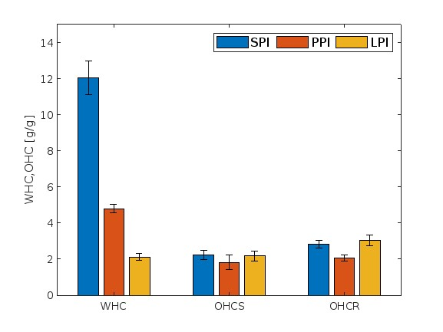
  - Results & Discussion
Figure 1: Water-/oil holding capacity of legumes (WHC/OHC) S = sunflower oil, R = rape oil. With SPI (soy protein isolate), PPI (Pea protein isolate) and LPI (Lupin protein isolate).
Due to the ingredients and manufacturing methodology, the classic hollandaise sauce is both an emulsion and a foam. Although, the impact of air in the industrial substitutes, largely occurs during heating in the saucepan. Therefore, the functional properties focus on the influences of water/oil holding capacity, emulsion properties and foam formation properties.

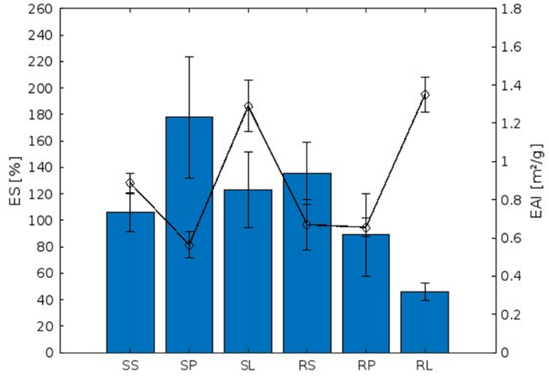
3.1 Water-/oil holding capacity (WHC/OHC) Concerning the WHC and OHC, it is noticeable that the protein isolates bind more water (2.12 g/g - 12.04 g/g) than oil (1.81 g/g - 3.05 g/g) (Figure 1) except for LPI. Probably, LPI shows a higher hydrophobicity and the aliphatic chains of the lipids can better interact with the nonpolar side chains of the amino acids (Sanjeewa et al., 2010). The water binding capacities of the three protein isolates differ significantly in contrast to the OHC. The SPI binds the most water, which could be related to the high amount of the hydrophilic amino acids on the covering of globular soy protein (Gorissen et al., 2018). Furthermore, the prevailing pH and the different isoelectric points could also influence the WHC. For these measurements, the given pH value: SPI: 8.61 (±0.01), PPI: 7.64 (±0.01) and LPI: 7.07 (±0.01) of the suspension was used and no uniform settings were made. According to (Tsumura et al., 2005) the isoelectric point (IEP) of soybean is about 4.50, whereas a subunit of pea has an IEP of 8.8 (Heng et al., 2004). Also in lupin, one subunit has a value of 8.51 (Shrestha et al., 2021). Here it is noticeable that the range of the isoelectric point of pea and lupin overlaps with the existing pH values for PPI and LPI, which can lead to a lower WHC (Damodaran, 2005). When comparing WHC to the literature, it should always be kept in mind that the methodology used greatly affects the results. According to (Kinsella, 1979), the increase form pH 5 to pH 7 resulted in a sixfold increase in WHC. For a PPI from the same product series (Pisane HD) (Fuhrmeister and Meuser, 2003) quantify a WHC of ~4.0 g/g, which is close to the analyzed value. LPI shows a significantly lower WHC than SPI and PPI. The poorer WHC of lupin is also confirmed by (Rodríguez-Ambriz et al., 2005). The determined value of 2.12 g/g is very similar to isolates obtained by acid precipitation (225.7 g/100 g) (El-Adawy et al., 2001).
Figure 2: Emulsion stability (ES) and activity index (EAI) of legume proteins, S = sunflower oil, R = rape oil, S = SPI (soy protein isolate) , P = PPI (pea protein isolate), L= LPI (lupin protein isolate)
The OHC of SPI (2.25 g/g, 2.81 g/g) and LPI (2.18 g/g, 3.05 g/g) are higher than the values of PPI (1.81 g/g, 2.08 g/g). However, only significant differences are present for rape oil whereby SPI with PPI and LPI with PPI differ significantly. OHC with rape oil shows slightly higher values than with sunflower oil (+0.04 g/g - 0.87 g/g). There is, only a significant difference recognizable at LPI. In comparison to other authors, (Fuhrmeister and Meuser, 2003) determines an OHC of 1.23 g/g for the SPI (Soyamin90) and 0.87 g/g for PPI (PisaneHD), whereas (Tomotake et al., 2002) determines an OHC of 2.61 g/g for SPI and the PPI according to (Soetrisno and Holmes, 1992) exhibit (5.34 g/g). These differences may be a consequence of the different methodologies and vegetable oils applied. Furthermore, (Muranyi et al., 2016) determined an OHC value for isoelectric precipitated LPI of 0.85 g/g and (El-Adawy et al., 2001) 285.4 g/100 g for micellized LPI.
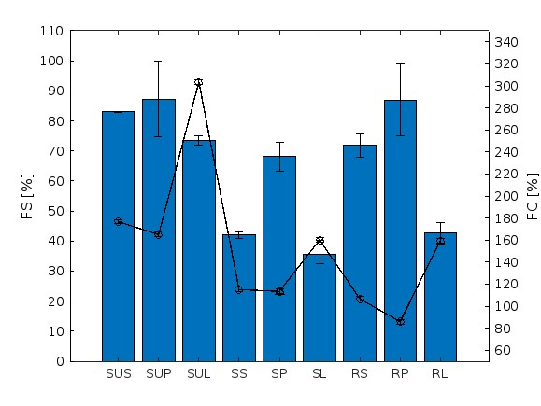
3.2 Emulsion activity index (EAI) and Emulsion stability (ES):
Figure 2: Foaming properties of legumes: SU =suspension with water, S= sunflower oil, R = rape oil, S = SPI (soy protein isolate), P = PPI (pea protein isolate), L= LPI (lupin protein isolate)

EAI results vary between (0.56 m²/g and 1.35 m²/g) for the non-heated samples (Figure 2). LPI (1.29 m²/g, 1.35 m²/g) shows significantly higher values than SPI (0.89 m²/g, 0.67 m²/g) or PPI (0.56 m²/g, 0.66 m²/g) for both sunflower and rape oil. Other studies have tended to measure higher values, but these vary widely depending on the study. The reason for this could be the different measurement conditions, such as protein-/oil concentration, pH, etc.. For example, (Barac et al. 2010) showed that EAI has significant differences within a genotype at pH values from 3 to 8. In an experimental line L2, a variation of even approximately (40 - 260 m²/g) was recorded. Furthermore, the oil type and concentration also exert an influence on the EAI. According to (Gu et al., 2009) a 20 % emulsion with palm stearin oil has an EAI of about (25 m²/g), whereas emulsions with sunflower oil and soybean oil show values of about (11 m²/g). Except for RP and RL, the heating step increases the EAI (ES over 100 %). This is due to a partial denaturation of the globular proteins, exposing hydrophobic groups in the core (Damodaran, 2005).
    - Foam capacity (FC) and Foam stability (FS)
Table 1: Sauce samples

Sauce | Abb.
6 % SPI, 35% S | S1
6 % SPI, 35% R | S2
7 % SPI, 35% S | S3
7 % SPI, 35% R | S4
8 % PPI, 40% S | P1
8 % PPI, 40% R | P2
9 % PPI, 30% S | P3
9% PPI, 30% R | P4
10% LPI, 40% S | L1
10% LPI, 40% R | L2
14% LPI, 30% S | L3
14% LPI, 30% R | L4
Table 1: Sauce samples
 | Sauce | Abb.
6 % | SPI, 35 % S | S1
6 % | SPI, 35 % R | S2
7 % | SPI, 35 % S | S3
7 % | SPI, 35 % R | S4
8 % | PPI, 40 % S | P1
8 % | PPI, 40 % R | P2
9 % | PPI, 30 % S | P3
9 % | PPI, 30 % R | P4
10 % | LPI, 40 % S | L1
10 % | LPI, 40 % R | L2
14 % | LPI, 30 % S | L3
14 % | LPI, 30 % R | L4
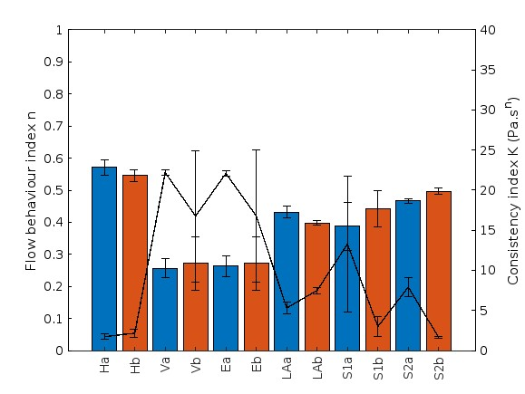
In terms of foam capacity, the emulsions have significantly lower values (85. 83 %-160.00 %) than the suspensions with water (165.00%-303.33%) in relation to the respective protein isolate (Figure 3). Lipids displace proteins from the gas surface due to their hydrophobicity without being able to form stable films themselves (Belitz et al., 2009). LPI has significantly higher FC in all categories compared to SPI and PPI. This is in contrast with the results of (Rodríguez-Ambriz et al., 2005). Probably the purification methodology plays a greater role here and positively influences the lupin protein isolate to properties, like low molecular weight, high surface hydrophobicity, good solubility a small net charge in terms of pH, and easy denaturability, resulting in better FC (Belitz et al., 2009). Concerning that (Rodríguez-Ambriz et al., 2005) determined an FC difference of approximately 400 % between micellar and isoelectric precipitated SPI at pH 4. In addition to the foam capacity, the foam stability also plays an important role in characterizing the foaming properties in more detail. In contrast to the foam capacity, LPI does not achieve the highest values for the FS. LPI has the lowest value in each case and even the significantly lowest for the emulsions. Thus, LPI can form a large interface but not stabilize it for long in comparison to SPI and PPI. Furthermore, the emulsions do not always show significantly lower foam stabilities. Therefore, the oil influences negatively the foam formation but not mandatory stability. In contrast to the suspensions the emulsions differ significantly from each other (sunflower: PPI with SPI and LPI; rape oil: LPI with SPI and PPI).
Figure 4a: Consistency index and flow behaviour of reference products and Sauces with SPI (soy protein isolate); a = 65 °C, b = 100 °C
3.4 Rheological Measurements
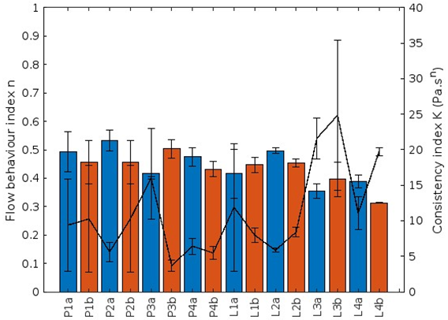
Throuch the preliminary tests, the sauces described in Table 1 were evaluated as most suitable. However, during the measurements of the flow properties it was found that the samples S3 and S4 have a too solid structure. These cannot be detected by the given measurement conditions and therefore there are excluded from the following evaluation. The Herschel Bulkley model turns out to be a good approximation model with R² 0.98-1.00. This has already been observed by other authors in mustard sauce (Wang et al., 2016) and meat sauce (Okonkwo et al., 2021). Regarding the flow properties, all sauces exhibit shear-thinning behaviour, because all n-values are less than one (Figures 4a and 4b). This flow behaviour was also observed for meat sauces, white sauces and chili sauces at room temperature (Okonkwo et al., 2021; Gamonpilas et al., 2011; Bortnowska et al., 2014) For starch-based sauces (reference products), this behaviour can be explained by the disentanglement of polymer chains and its subsequent re-alignment in the direction of flow (Hosseini-Parvar et al., 2010). Presumably, the protein structures also unfold and arrange themselves in the direction of flow. Furthermore, there are no significant differences in the n-values about the heating levels (65 °C/100 °C). This contrasts with the results of (Okonkwo et al., 2021; Koocheki et al., 2009; Sagdic et al., 2015), who studied meat sauce, tomato ketchup and rose hip marmalade. Here, decreasing n-values were observed with increasing temperature and thus the pseudoplastic behavior was enhanced by heating. The sauces LA (100 °C), S1 (65 °C), L3 and L4 differ significantly from the animal-based hollandaise sauce. The consistency index K has values ranging from 1.63-24.85 Pas^{n} (Fig 4a and 4b). Also (Okonkwo et al., 2021) obtained similar results except for one meat sauce. Furthermore, no significant differences are discernible either in terms of the raw materials or the different heating stages. However, it is noticeable that the animal-based sauce hollandaise has low values in comparison.
Figure 4b: Concistency index and flow behaviour of sauces with PPI (pea protein isolate) and LPI (lupin protein isolate); a = 65 °C, b =100 °C
Conclusion
The functional properties of plant proteins are influenced not only by the variety itself but also by extrinsic factors, such as the prevailing pH-value. Furthermore, factors like purification methodology and genotype also play a major role. Therefore, functional properties should always be evaluated in the context of the above factors. More in-depth measurements are needed (oil/protein proportions, other protein raw materials, and the sensory properties) to better evaluate the potential of vegetable proteins for the product application Hollandaise sauce. In addition, a classic hollandaise sauce contains lemon juice or vinegar, which changes the pH value. Because of this, the factor of the pH-value should be included in the measurements to imitate a hollandaise sauce as best as possible. Nevertheless, vegetable proteins show the potential to act as a structuring substance in hollandaise sauce products.

References
Belitz H. D., Grosch W.,Schieberle P., 2009, Food Chemistry
Beuchat L. R., 1977, Functional and electrophoretic characteristics of succinylated peanut flour protein, Journal of agricultural and food chemistry, 25, 258–261
Bortnowska G., Balejko J., Schube V., Tokarczyk G., Krzemińska N.,Mojka K., 2014, Stability and physicochemical properties of model salad dressings prepared with pregelatinized potato starch, Carbohydrate polymers, 111, 624–632
Damodaran S., 2005, Protein Stabilization of Emulsions and Foams, Jornal of Food Science, 70, R54-R66
El-Adawy T. A., Rahma E. H.,El-Bedawey,A.A., Gafar, A.F., 2001, Nutritional potential and functional properties of sweet and bitter lupin seed protein isolates, Food chemistry, 74, 455–462
Fuhrmeister H.,Meuser F., 2003, Impact of processing on functional properties of protein products from wrinkled peas, Journal of Food Engineering, 56, 119–129
Gamonpilas C., Pongjaruvat W., Fuongfuchat A., Methacanon P., Seetapan N.,Thamjedsada N., 2011, Physicochemical and rheological characteristics of commercial chili sauces as thickened by modified starch or modified starch/xanthan mixture, Journal of Food Engineering, 2, 233–240
Gorissen S. H. M., Crombag J. J. R., Joan M. G. S., Waterval W. A. H., Bierau J., Verdijk L. B.,van Loon, L. J. C., 2018, Protein content and amino acid composition of commercially available plant-based protein isolates, Amino acids, 12, 1685–1695
Gu X., Campbell L. J.,Euston S. R., 2009, Effects of different oils on the properties of soy protein isolate emulsions and gels, Food Research International, 8, 925–932
Heng L., van Koningsveld G.A., Gruppen H., van Boekel M.A.J.S., Vincken J.-P., Roozen J.P.,Voragen A.G.J., 2004, Protein–flavour interactions in relation to development of novel protein foods, Trends in Food Science & Technology, 3-4, 217–224
Hopia A., Sillanpää M.,Tuomisto M., 2013, Hollandaise sauce and the chemistry behind old and new preparation techniques, LUMAT, 2, 189–195
Hosseini-Parvar S. H., Matia-Merino L., Goh K.K.T., Razavi S.M.A.,Mortazavi S. A., 2010, Steady shear flow behavior of gum extracted from Ocimum basilicum L. seed: Effect of concentration and temperature, Journal of Food Engineering, 3, 236–243
Ibanoglu E.,Erçelebi E. A., 2007, Thermal denaturation and functional properties of egg proteins in the presence of hydrocolloid gums, Food chemistry, 2, 626–633
Kinsella J. E., 1979, Functional properties of soy proteins, Journal of japan oil chemists' society, 56, 242–257
Kiosseoglou V., 2003, Egg yolk protein gels and emulsions, Current Opinion in Colloid & Interface Science, 4-5, 365–370
Koocheki A., Ghandi, A. Razavi, S. M. A., Mortazavi S. A.,Vasiljevic T., 2009, The rheological properties of ketchup as a function of different hydrocolloids and temperature, International Journal of Food Science & Technology, 3, 596–602
Lam A. C. Y., Can Karaca A., Tyler R. T.,Nickerson M. T., 2018, Pea protein isolates: Structure, extraction, and functionality, Food Reviews International, 2, 126–147
Lo B., Kasapis S.,Farahnaky A., 2021, Lupin protein: Isolation and techno-functional properties, a review, Food Hydrocolloids, 3, 106318
Muranyi I. S., Otto C., Pickardt C., Osen R., Koehler P.,Schweiggert-Weisz U., 2016, Influence of the Isolation Method on the Technofunctional Properties of Protein Isolates from Lupinus angustifolius L, Journal of food science, 11, C2656-C2663
Okonkwo V. C., Mba O. I., Kwofie E. M.,Ngadi M. O., 2021, Rheological Properties of Meat Sauces as Influenced by Temperature, Food and Bioprocess Technology, 11, 2146–2160
Pearce K. N.,Kinsella J. E., 1978, Emulsifying properties of proteins: evaluation of a turbidimetric technique, Journal of agricultural and food chemistry, 26, 716–722
Rodríguez-Ambriz S. L., Martínez-Ayala A. L., Millán F.,Dávila-Ortíz G., 2005, Composition and functional properties of Lupinus campestris protein isolates, Plant Foods for Human Nutrition, 3, 99–107
Sagdic O., Toker O. S., P. B., A. M.,Y. M. T., 2015, Bioactive and rheological properties of rose hip marmalade, Journal of food science and technology, 10, 6465–6474
Sanjeewa T. W. G., Wanasundara J. P.D., Pietrasik Z.,Shand P. J., 2010, Characterization of chickpea (Cicer arietinum L.) flours and application in low-fat pork bologna as a model system, Food Research International, 2, 617–626
Sha L.,Xiong Y. L., 2020, Plant protein-based alternatives of reconstructed meat: Science, technology, and challenges, Trends in Food Science & Technology, suppl_3, 51–61
Shrestha S., Leonie van 't Hag, Haritos V. S.,Dhital S., 2021, Lupin proteins: Structure, isolation and application, Trends in Food Science & Technology, 928–939
Siebeck W., 1990, Cooking school for the demanding (in German)
Soetrisno U. S. S.,Holmes Z. A., 1992, Functional properties of acid and salt extracted proteins of yellow peas (Pisum sativum L. Miranda), Journal of agricultural and food chemistry, 40, 975–980
Tomotake H., Shimaoka I., Kayashita J., Nakajoh M.,Kato N., 2002, Physicochemical and functional properties of buckwheat protein product, Journal of agricultural and food chemistry, 7, 2125–2129
Tsumura K., Saito T., Tsuge K., Ashida H., Kugimiya W.,Inouye K., 2005, Functional properties of soy protein hydrolysates obtained by selective proteolysis, LWT - Food Science and Technology, 3, 255–261
Wang T., Zhang M., Fang Z., Liu Y.,Gao Z., 2016, Rheological, Textural and Flavour Properties of Yellow Mustard Sauce as Affected by Modified Starch, Xanthan and Guar Gum, Food and Bioprocess Technology, 5, 849–858
Watanabe M., Shimada A.,Arai S., 1981, Enzymatic Modification of Protein Functionality: Implantation of Potent Amphiphilicity to Succinylated Proteins by Covalent Attachment of Leucine Alkyl Esters, Agricultural and Biological Chemistry, 7, 1621–1625
Wong P. Y. Y.,Kitts D. D., 2003, A Comparison of the Buttermilk Solids Functional Properties to Nonfat Dried Milk, Soy Protein Isolate, Dried Egg White, and Egg Yolk Powders, J. Dairy Sci., 86, 746–754

